Q6. How will Mashiach Redeem the Jewish People?
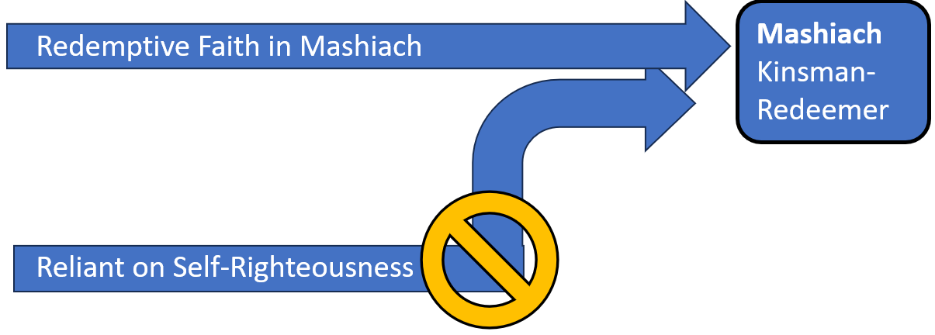

The Biblical model of redemption is a “redemptive faith,” a faith placed squarely in God’s promised Zera- Seed, that is Mashiach, to do what is humanly impossible. So, Adam and Eve, clothed only in haphazard fig leaves, could only trust in the promised Zera of the woman (Gen. 3:15) to dethrone the serpent who had deceived them, even hoping that child after child might be the “Lord” (Gen. 4:1) or “other Seed” (Gen. 4:25) to save them. Abraham, confronted by his Idead flesh and lonely isolation amidst strangers, could only hope in the promised Zera to multiply life to bless all families of the earth (Gen. 22:17-18). David, well aware of his “sin… ever before” him (Ps. 51:3), could only repent and rely on the Lord’s “mercy” (Ps. 51:1) and promise of an over-ruling Seed (2 Sam. 7:12-14) rather than any self-made “sacrifice” he could muster (Ps. 51:16).
This redemptive faith of the patriarchs and prophets counted them and others in Israel as righteous (Gen.15:6), those who looked forward in hope to the promised Mashiach. However, those like Saul who rely on themselves (1 Sam. 15:12) offer God sacrifices of their own choosing (1 Sam. 15:22) and a righteousness and man-made holiness secured by their own hands (Is. 65:5). But, those with a redemptive faith call out: “The Lord is our righteousness” (Jer. 23:6).
Thus, in Israel’s history, we see these two paths to righteousness. Those with redemptive faith are often tested and opposed by those who are Self-Righteous. Still, through the age of the patriarchs and the prophets, many in Israel looked forward by faith to the promised Mashiach, a green and supple “olive tree” before the Lord of hosts (Zech. 4:3). But, when the Lord God “raised up” Jesus Mashiach as the Seed of David according to the time revealed to Daniel (Dan. 9:25), many who recognized Him as the Mashiach were the first to form the seven “lamps” of the Church Age (Zech. 4:2), while their Jewish brethren who needed no redemption due to their own Self-Righteousness rejected Jesus as their Mashiach and were cast into the spiritually dark wilderness as a withered and abandoned tree.
One day, however, Jesus Mashiach will return to redeem Israel and lead it to repentance. Then, all Israel will be redeemed. Here are the events of Israel’s redemption that are still to come:
1. Wilderness: Frozen Prophetic Time:
In the Lord God’s timeline from Exile to Mashiach and the End, the 69 weeks (of years) would culminate in the “anointed one” “putting an end to sin” by “atoning for iniquity to bring in everlasting righteousness” (Dan. 9:24). But, before the final, terrible last “week” could commence, Israel rejected Jesus as its Mashiach, and the Lord God froze the prophetic time sequence. For, during this barren darkness, Israel would wander among the nations as Jesus predicted (Luke 21:24) until the Lord God regathers Israel to the land of Israel (Eze. 37:12). All the while, the seven lamps of the Church Age (Zech. 4:2) bore witness of Jesus Mashiach to the world. Though imperfect in understanding (Rom. 10:19) and hampered by the flesh, the Church testified of Jesus Mashiach during Israel’s wandering. But, as the Church age draws to a close, Israel revives again as her appointment with Jesus Mashiach draws near.
2. First Fruits: Fruitfulness and Forewarning:
As the day of Israel’s redemption and her reunion with Jesus as her Mashiach draws near, the “fig tree” of Israel and its branches will “become tender and put out its leaves” (Matt. 24:32). Many Jews will rediscover their Redemptive Faith and will seek for their Mashiach, and many will come to Jesus for salvation.
At this time, a remnant will realize that the Church testified truly of Jesus as the Mashiach (Rev. 3:?), and they will repent when they witness the mass evacuation of the Church from the time of testing coming upon the world (Rev. 3:10?).
Thus, the believing remnant of Israel will begin to proclaim Jesus as Mashiach in the land, to great opposition and persecution. However, the Lord Jesus Mashiach himself confirms their witness, as “the Son of Man” returns to save and reveal Himself to all of Israel (Matt. 10:23).

3. Birth Pains: Frequency of Testing
In order to prepare Israel

4. Day of the Lord: Firstborn Recognized

5. Tribulation: Fully Proclaiming Jesus Mashiach

6. Great Tribulation: Frightful Rule of Antichrist.

7. Millennial Paradise and Eternity: Final Kingdom Established

